EXERCISE NO:3

DATE:11/10/2020

AIM:

 To remove and print every second number from a list of numbers until the list becomes empty.

PROGRAM:

def remove1(list):

list1=[]

pos=1

s=0

for i in range(0,len(list)):

s=(pos+s)%len(list)

e2=list.pop(s)

list1.append(e2)

return list1

n=int(input())

int_list=[]

for i in range(0,n):

e=int(input())

int_list.append(e)

p=remove1(int_list)

print(p)

LINK:

<http://103.53.53.18/mod/vpl/forms/edit.php?id=231&userid=1678>

OUTPUT:

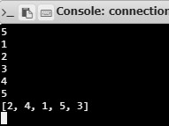

RESULT:

Hence, every second number removed and printed from a list of numbers until the list becomes empty